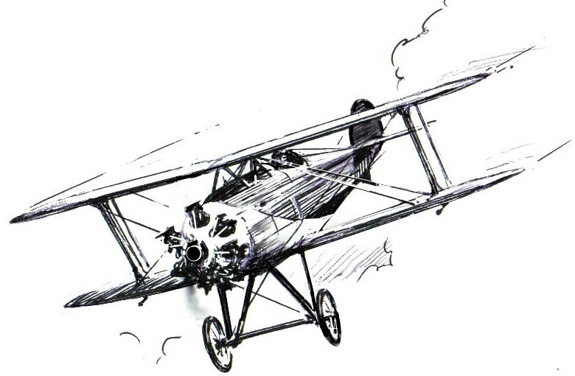
Swindon Aircraft Timber Company

Field Rise, Kite Hill, Wanborough, SN4 0AW

Telephone +44 (0)1793 791517

Mobile 0799 097 6393 Email dudleypattison@btinternet.com
http://www.aircraftplywoodandtimber.co.uk

Duds suggested tool list for woodwork on aircraft

Measuring
Rules 6”, 12”, 24”, 36” steel
5mtr Tape measure
HB pencils
Squares, large and small

Cutting
Bandsaw 1/4” or 3/8” blade, 10 to 14TPI
*Razor saw
*Chisel set
*Bull nose plane
Small smoothing plane
Stanley/craft knife

Drilling
3/8” chuck pillar drill
Cordless drills, medium size and small
*Drill guide block (home made, block of steel drilled to required sizes to aid drilling square to a surface)
Drill bits including centre drill
*Flat bits
Hole saw and/or Trepanning tool

Sanding
12” dia disc sander
*Selection of ‘Permagrit’ hand sanding tools
*Mini drill with sanding discs
*B&D powerfile
120 & 240 grit coated free-cut sanding sheets (3M)
60 grit aluminium oxide sanding sheets

Clamping
2”, 3”, 4” and 6”G clamps
*Sash clamps
Spring clamps
Staple gun with 10mm staples

* Not as essential as other items, but desirable.

